_________________________________________________________________________

Section 3: Requirements Gathering - Computer Literacy Hub

This section describes the core user flows, specific functional requirements, and technical approach to data handling for the Computer Literacy Hub application.
_________________________________________________________________________

Architectural Diagram of the Application (Workflow Diagram)
This architecture uses Menu-Driven Console Architecture. The diagram below illustrates the flow:

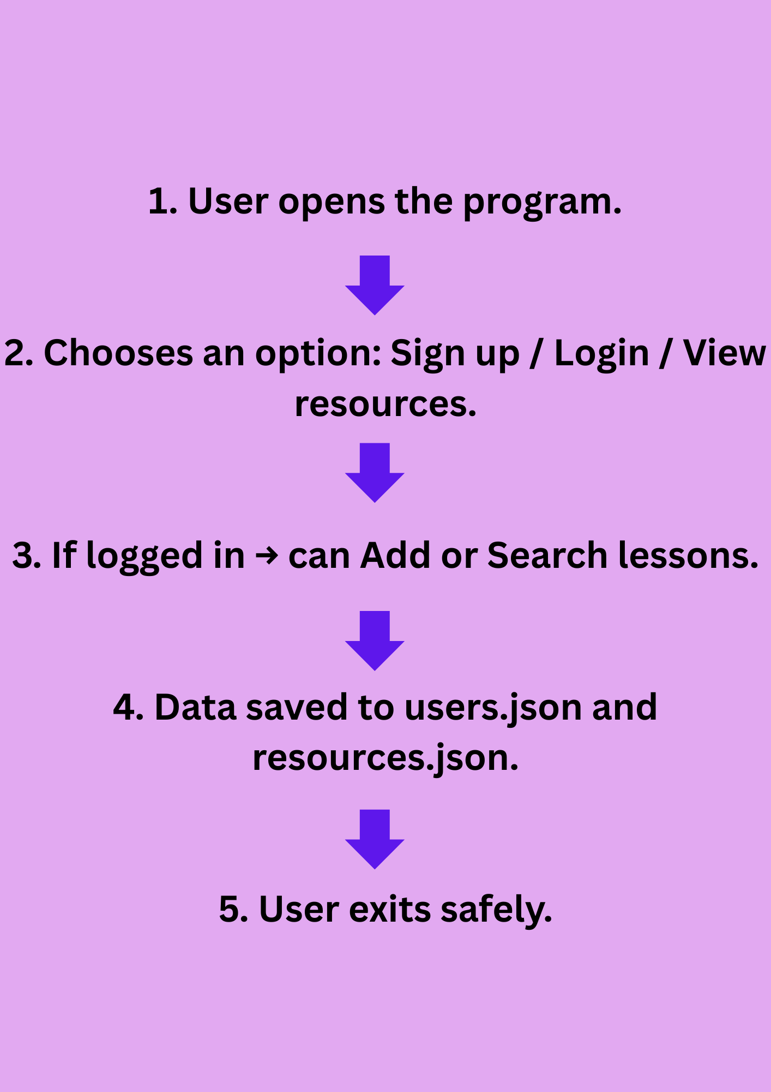

Screenshot of the App
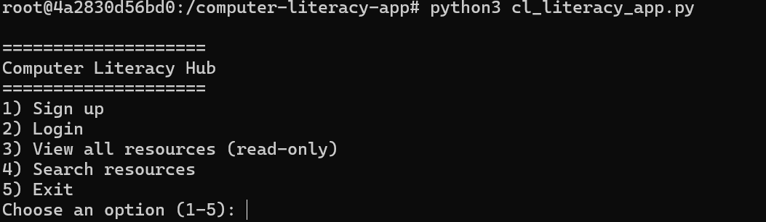

Users Workflow Steps:
- Launch and Main Menu: The user executes the python script, and the application loads the main menu, prompting for choice (1-5)
- Authentication Branch:
Guest (Not logged in): Can sign-up, Log in or proceed to search/view resources.
Authenticated User (Logged in): Can add a resource, Search, View, Log out.

Feature Description
In this section, we detail the key features of Computer Literacy Hub with some screenshots for better understanding.

Part 1: Functionality of the Software
- User Authentication (Sign up & Log in): Users create accounts by choosing option 1 and inputting a user name and password. The application uses getpass to hide the password input and SHA256 to securely store the password hash in users.json
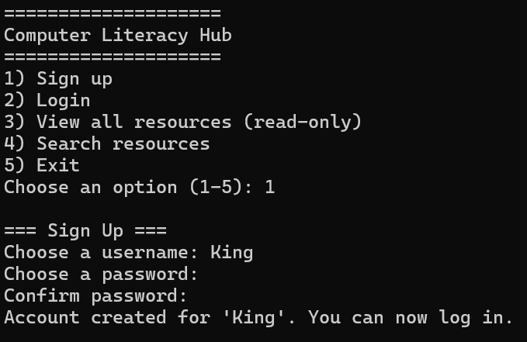

- Add New Educational Resources: A feature exclusive to authenticated users, allowing them to contribute learning materials. It prompts for the resource’s Title, Description and Level (Beginner,Intermediate,Advanced) and descriptive tags.
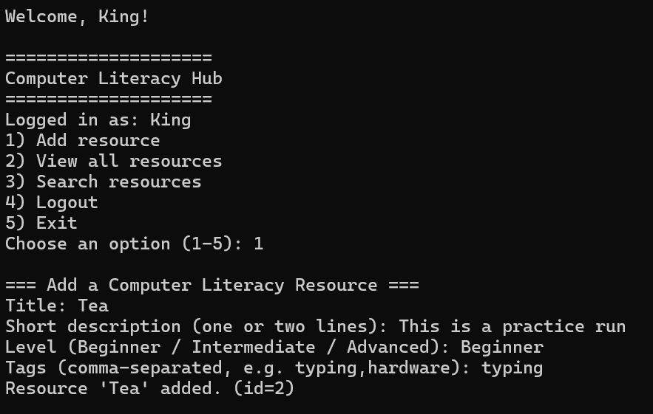

- View all Resources: Allows any user (Guest or Authenticated) to read a formatted list of all contributed resources, including ID ,Titles, Level, Author, and Tags.
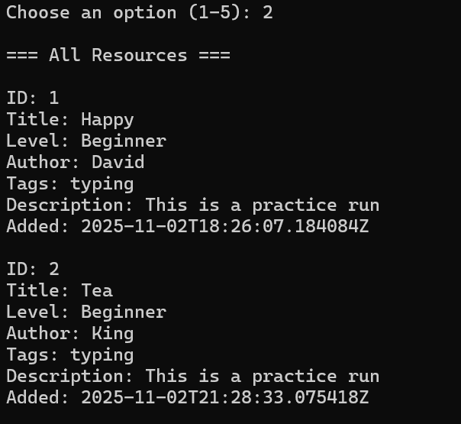

- Search: The core discovery tool. Users can search by tags, Author or Level to find specific materials.
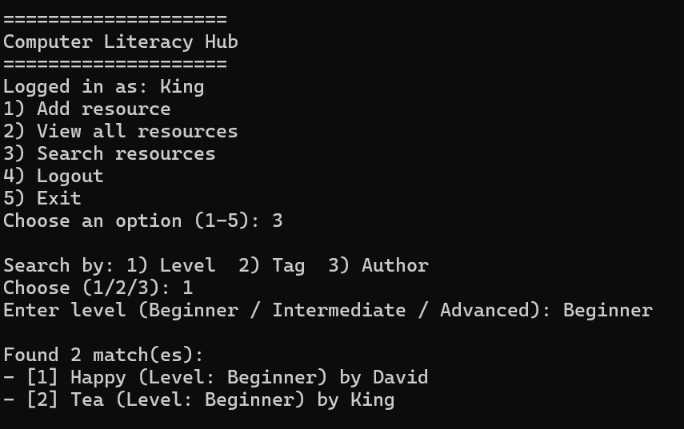

- Log out and Exit: An authenticated user can logout after viewing, searching or adding resources to the app. After that the user will be taken to the main menu where he/she can choose to exit the app.
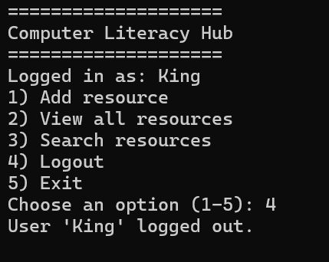

Part 2: Data Handling and Storage of the Computer Literacy App
What kind of data will used by the solution
- User Data: Username (key), SHA256 hashed password, and account creation timestamp.

- Resource Data: Resource ID, Title, Description, Learning Levels, List of Tags, Author, Creation timestamp.

How the user will leverage the data from the software solution
The user interacts with data in three ways
- Contribution: The user writes resource data when using the add resource feature

- Discovery: User reads resource data when viewing or searching for educational materials. The applications search feature directly leverages the Level and Tags fields for filtering.

- Security: The user provides credentials which are compared against the stored users data hash for authentication.

How will the data be stored in the solution
Data is stored persistently on the local file system using two separate JSON files
- users.json: Stores a dictionary connecting usernames and passwords.

- resources.json: Stores a list of all resource objects.

Where does data usage come into the development process of the solution

- File Initialization: The ensure_files() function ensures that the storage files exist before the main application logic runs.
- Input Validation: User-provided inputs like tags and levels are processed before being saved to ensure consistent search results
- Hashing and Comparison: Data usage is crucial for security during login, where the inputted password is hashed and compared against the stored hash in the users.json file.
- Searching Logic: The search functions rely entirely on comparing input query strings (Level, Tag, or Author) against the fields of the loaded resource data in memory.

